Milestone 2 : Feature Engineering, Sentiment Analysis and Feature Integration

1. Introduction
After the successful data consolidation and cleaning in Milestone 1, Milestone 2 focused on constructing an advanced feature space for football player market value prediction. This phase involved systematic feature engineering, feature analysis, and the integration of sentiment-based attributes derived from social media data. In parallel, sentiment analysis was performed to capture public perception through probabilistic sentiment scores, which were aggregated at the player level and merged with football-related features. Feature redundancy and multicollinearity were analyzed to ensure robustness and interpretability. The resulting dataset is fully machine-learning-ready and forms the foundation for predictive modeling in the subsequent milestone.

2. Feature Engineering
Feature engineering was carried out to capture both short-term and long-term aspects of player performance and career progression. Raw cumulative statistics were normalized using per-90-minute metrics to account for differences in playing time. Additionally, rolling window features were introduced to capture recent form, which is known to be a strong indicator of current market valuation.
Temporal consistency was maintained by ensuring all time-dependent features were derived from standardized datetime fields. Table I summarizes the major categories of engineered features introduced during this milestone.
Table I: Feature Categories Introduced in Milestone 2
Feature Category | Description
Performance Trends | Rolling goals, assists, minutes, per-90 metrics
Contract Features | Age, contract duration, years remaining
Transfer Features | Number of transfers, fees, transfer recency
Injury Features | Injury count, days missed, injury frequency
Sentiment Features | Public perception and sentiment volatility

3. Performance Trend Feature Analysis
To capture player form beyond aggregate career totals, rolling averages were computed over recent match windows. These rolling metrics help identify performance momentum and short-term fluctuations, which are often reflected in transfer market valuations. Compared to static totals, trend-based features provide greater sensitivity to recent performance changes.
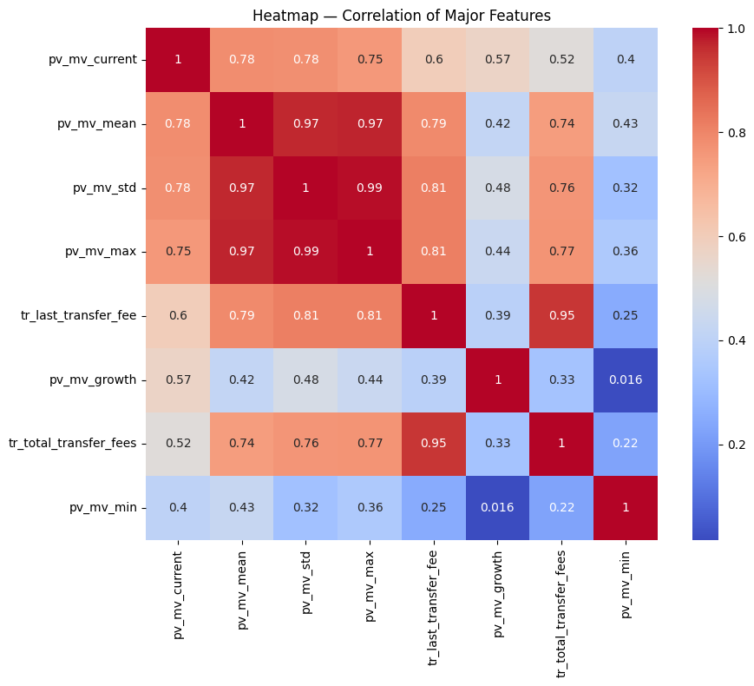

4. Injury and Contract-Based Features
Injury history was transformed into player-level indicators representing availability and risk. Aggregated measures such as total injury count, cumulative days missed, and average injury duration were computed. These features quantify physical reliability, which plays a crucial role in market valuation.
Contract-related features, including a) player age, b) contract expiration horizon, and c) years since last transfer, were derived from transfer and contract datasets. These features provide economic context, as players closer to contract expiry or with frequent transfers tend to have different valuation dynamics.

5. Sentiment Analysis Methodology
Public perception was incorporated into the player valuation framework through sentiment analysis of player-related social media data.Methods were selected due to their effectiveness on short, informal text commonly found on social media platforms.Each post was classified into positive, neutral, or negative sentiment categories, and probability scores were assigned accordingly. Sentiment analysis outputs were then aggregated at the player level to ensure consistency with the player-centric modeling framework adopted in this project.

6. Sentiment Feature Construction
For each player, sentiment features were derived using tweet-level sentiment probabilities and aggregated counts. The final sentiment feature set used in the project is summarized in Table II.

Table II: Player-Level Sentiment Features
Feature Name | Description
tweet_count | Total number of tweets associated with the player
prob_positive | Average probability of positive sentiment
prob_neutral | Average probability of neutral sentiment
prob_negative | Average probability of negative sentiment
positive_ratio | Ratio of positive tweets to total tweets
neutral_ratio | Ratio of neutral tweets to total tweets
negative_ratio | Ratio of negative tweets to total tweets
sentiment_score | Weighted sentiment polarity score
sentiment_score_norm | Normalized sentiment score
sentiment_volatility | Temporal variability of sentiment scores

7. Pseudo-Equations for Sentiment Score Calculation

A. Aggregated Sentiment Probabilities
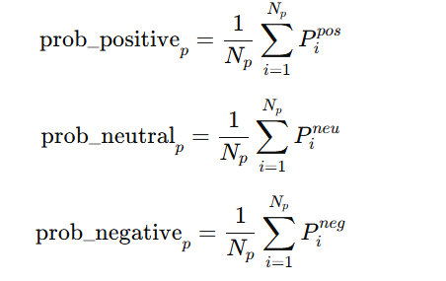
The average sentiment probabilities for a player .

B. Sentiment Ratio Features
Sentiment ratios represent the proportion of tweets falling into each sentiment category:
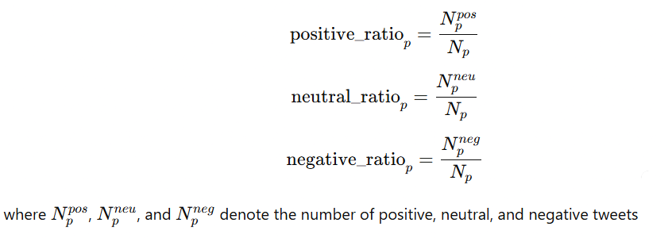

C. Normalized Sentiment Score
To ensure compatibility with machine learning models and prevent scale dominance, sentiment scores were normalized using min-max scaling:


8. Sentiment Analysis Insights
Exploratory analysis revealed that most players exhibit neutral to mildly positive sentiment, with a small subset showing high negative sentiment or high volatility. Players with larger tweet_count values generally demonstrated more stable sentiment scores, while players with fewer mentions exhibited higher variance. This suggests that sentiment reliability improves with volume and should be interpreted cautiously for low-visibility players.
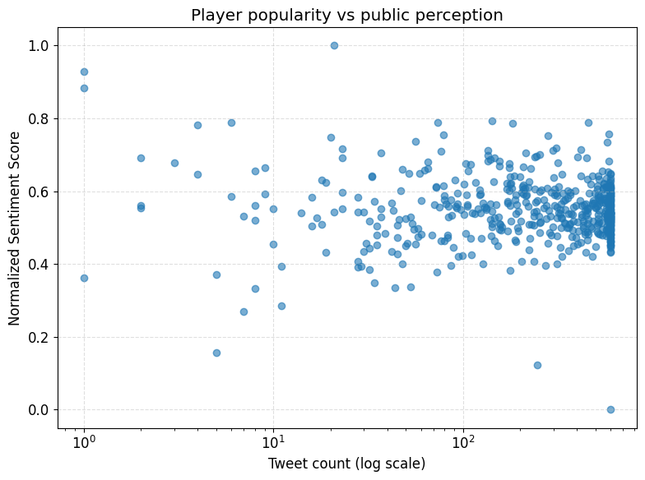

9. Integration with Football Features
All sentiment features were aggregated at the player level and merged with performance, injury, transfer, and team-related features using unique player identifiers. For players with missing sentiment data, neutral sentiment values were assigned to prevent systematic bias. Correlation analysis showed moderate relationships between sentiment scores and recent performance trends, reinforcing sentiment as a complementary rather than dominant predictive signal.

Milestone 2 Outcomes
So in this milestone we successfully transformed a cleaned dataset into a feature-rich, analytics-ready resource. By combining advanced football metrics with sentiment-based features, this stage significantly enhanced the dataset’s expressive power. The work completed in this milestone bridges raw data preparation and predictive modeling, ensuring that subsequent machine learning models are trained on meaningful, diverse, and high-quality inputs.

